**University of engineering & technology Peshawar**



**COMPUTER PROGRAMMING -LAB**

**Lab report # 2**

**Fall 2020**

**Submitted by: Ashfaq Ahmad**

**Section: B**

**Reg No: 19PWCSE1795**

**Semester: 2nd**

**Submitted to:**

**Eng: Abdullah**

**Department Of Computer System Engineering**

**Tasks**

**Task 1:** Write a program that takes the temperature in Fahrenheit and convert it to Celsius and Kelvin:

K = C + 273

C = (F – 32) / 1.8

**Source code:**

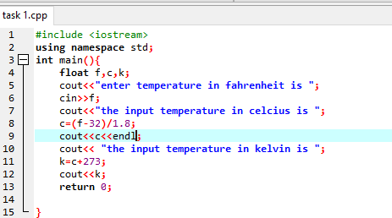

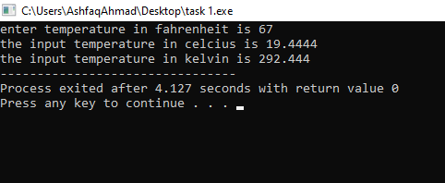**Compilation:**

**Task 2:** Write the C++ code that takes the integer a, b, c, d and e from the user and display the output according to the following equation.

a3 + b2 – d / b

a ( b + c ( e + a ) / b )- 10

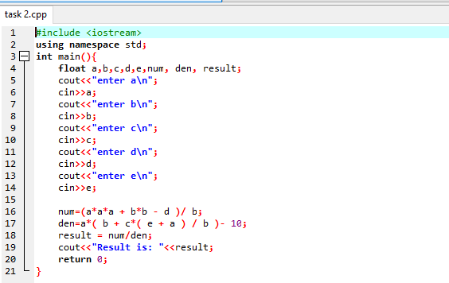**Source code:**

**Compilation:**

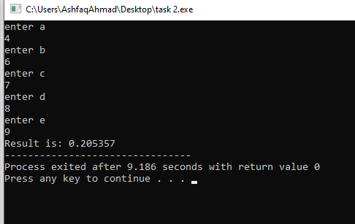

**Task 3:** Write a program to declare two integer and one float variables then initialize them to 10, 15, and 12.6. Also print the variable values on the screen.

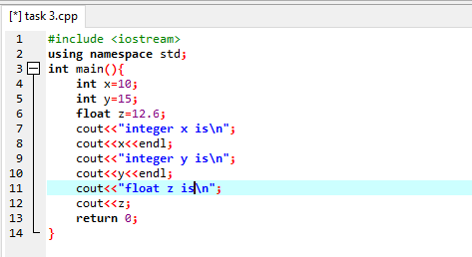**Source code:**

**Compilation:**

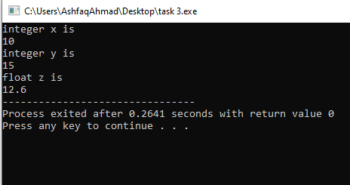

**Task 4:** Write a program to swap two variables values with and without using third variables.

**Source code:**

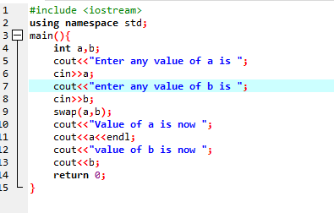

**Compliation:**

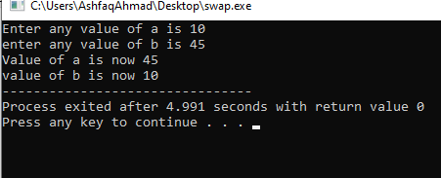

**Task 5:** Write a C++ program to prompt the user to input 3 integer values and print these values in forward and reversed order.

**Source code:**

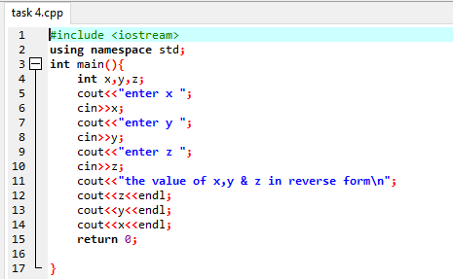

**Compilation:**

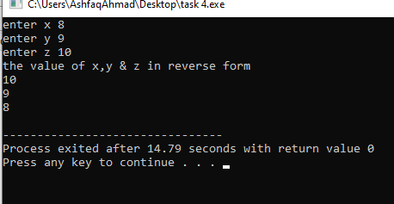

**Task 6:** Write a program to print the size of char, float, double and long double data types in C.

**Source code:**

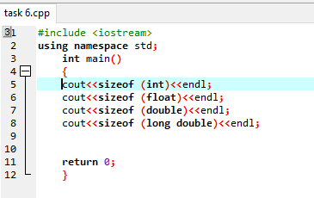

**Compilation:**

